SESSION 3

Q1) Draw the V-Model diagram on paper or using any digital tool, and clearly label each phase with both the developer and tester roles involved at each step.
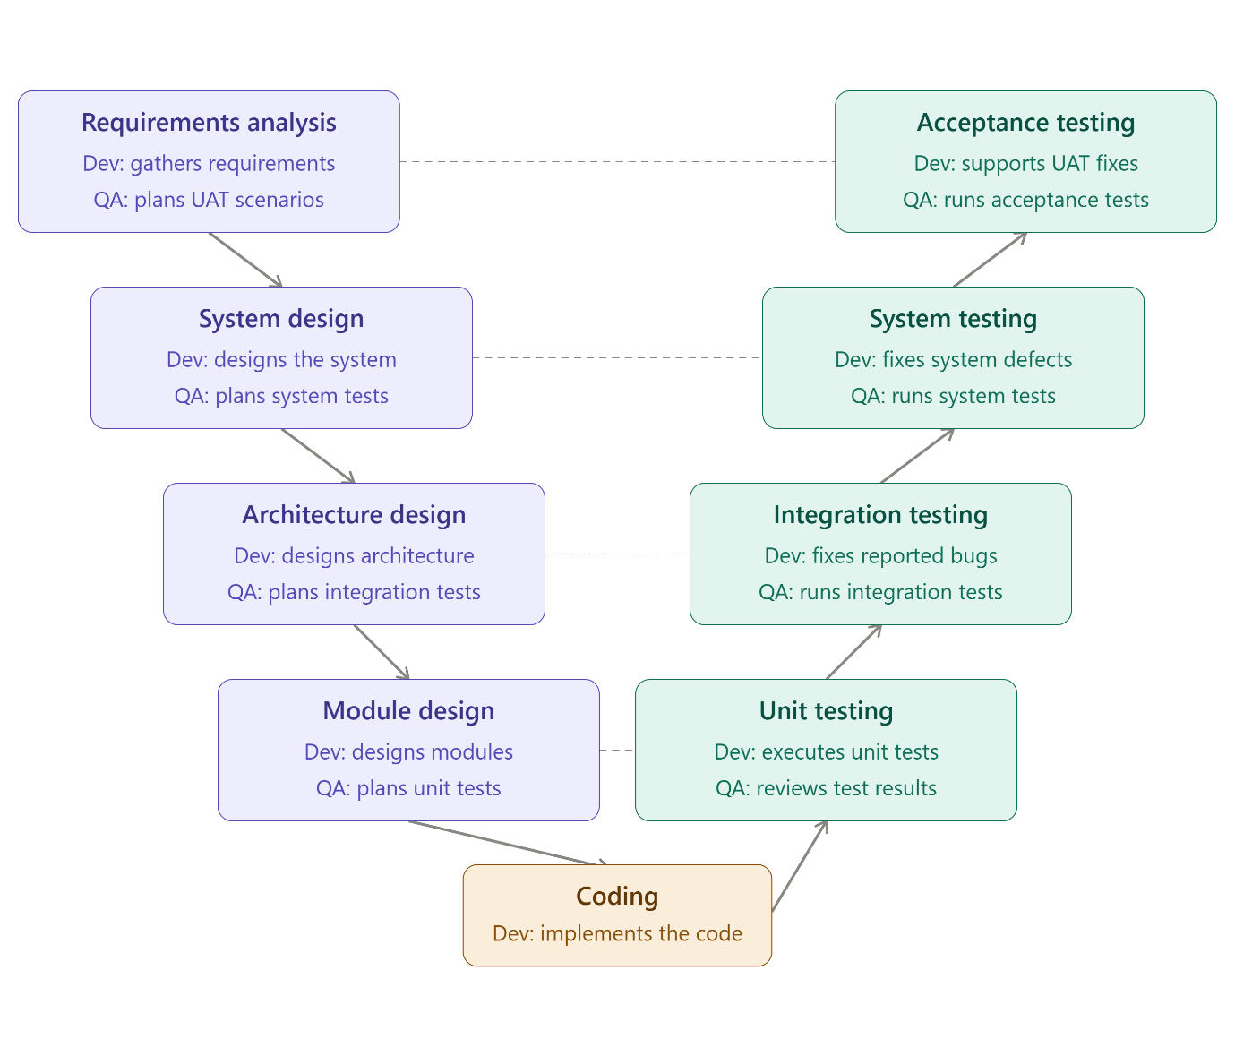

Q2) Pick any app you use daily (like Zomato, Instagram, or Paytm) and write a short table mapping each SDLC phase (Requirement, Design, Coding, Testing, Deployment, Maintenance) to a real activity that would happen for that app.
Requirement :Product team gathers feedback that users want a way to share content that disappears after 24 hours — this becomes the "Stories" feature requirement,
Design : UX designers wireframe the Stories tray at the top of the feed;
Coding :Mobile engineers build the camera/capture UI in Swift (iOS) and Kotlin (Android); backend engineers write the expiry service and media upload pipeline in the chosen server stack.
Testing :QA verifies Stories auto-delete after 24 hours, checks privacy settings (close friends, hidden from specific users)
Deployment :The feature is rolled out gradually — first to a small % of users in a few countries (canary release), monitored for crashes and load issues, then expanded globally.
Maintenance :monitor server load during viral events (e.g., a celebrity's Story going viral).

Q3) For each phase of the V-Model, list one specific testing activity that should be performed, using examples from a food delivery app (like Swiggy or Zomato).<br><br><em><strong>Hint:</strong> For example, during 'System Testing', you might test if the order placement works end-to-end.</em>.

Requirements Analysis : Verify that a real user can search for a restaurant, place an order, and receive it.
System Design ; test the order placement flow end-to-end — from adding items to cart, applying a coupon, choosing payment mode, to order confirmation.
Architecture/High-Level Design : Test the interaction between the Order Service and Payment Gateway.
Module/Detailed Design : Test the individual function that calculates the final bill (item price + taxes + delivery fee − discount).

Q4) ANSWER :
Aspect | V-Model | RAD Model
When testing is planned | Early (parallel with design) | Early (parallel with each prototype)
When testing is executed | Late (after full coding phase) | Continuous (per iteration)
Best for | Fixed, well-understood requirements (e.g., payment compliance) | Evolving requirements (e.g., new UI features, quick feature validation)
Risk | Late discovery of requirement flaws | Weak formal/non-functional test coverage

